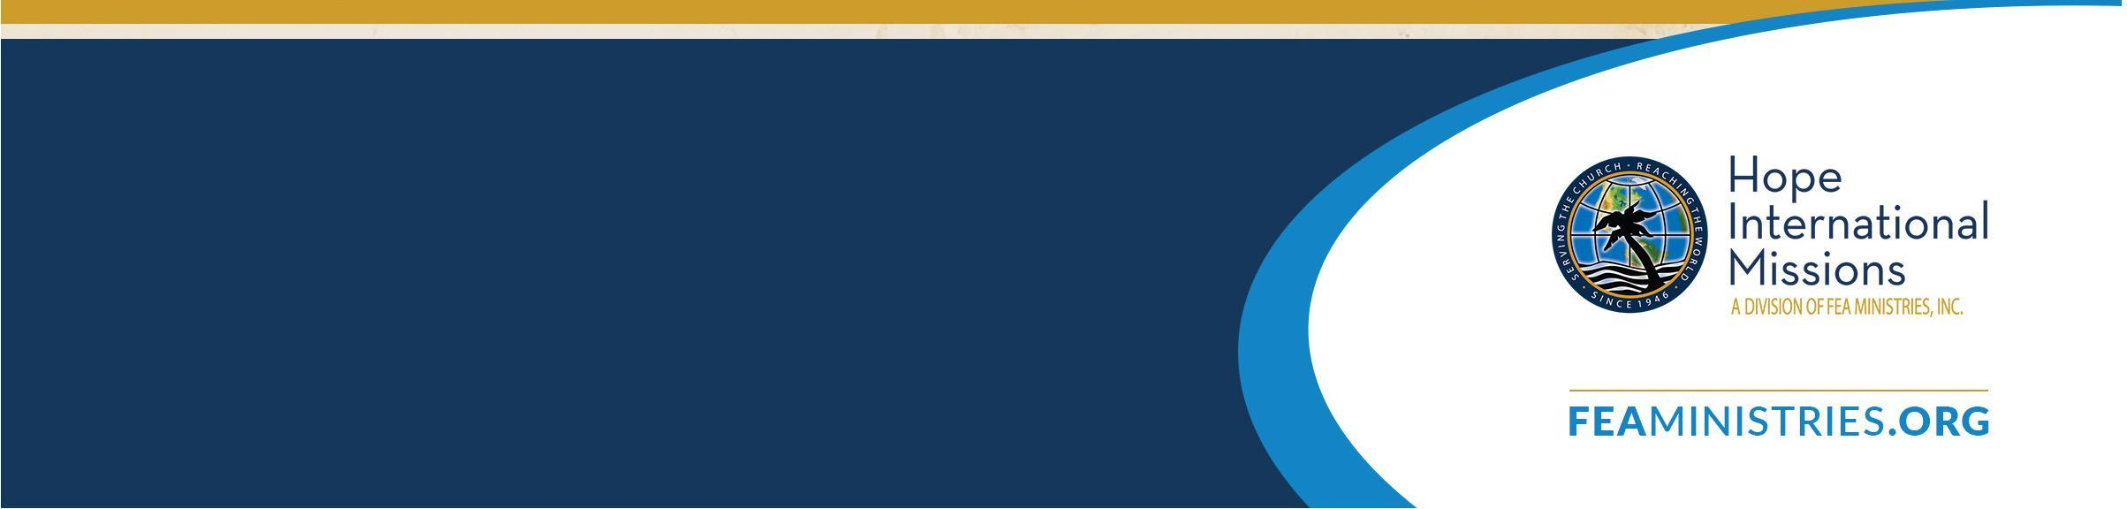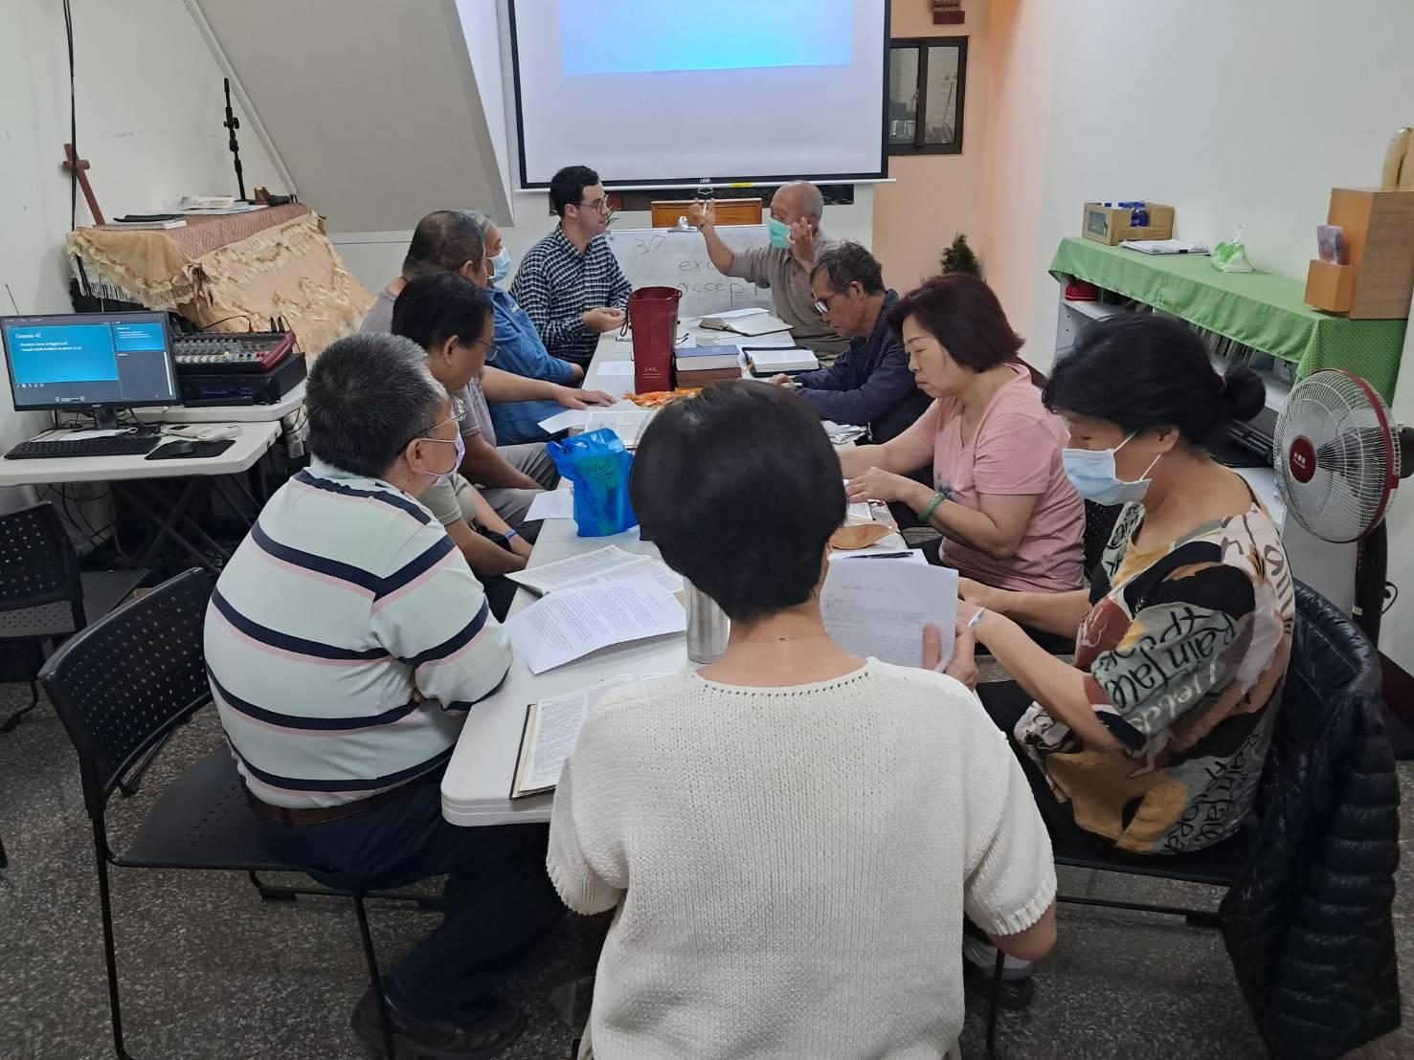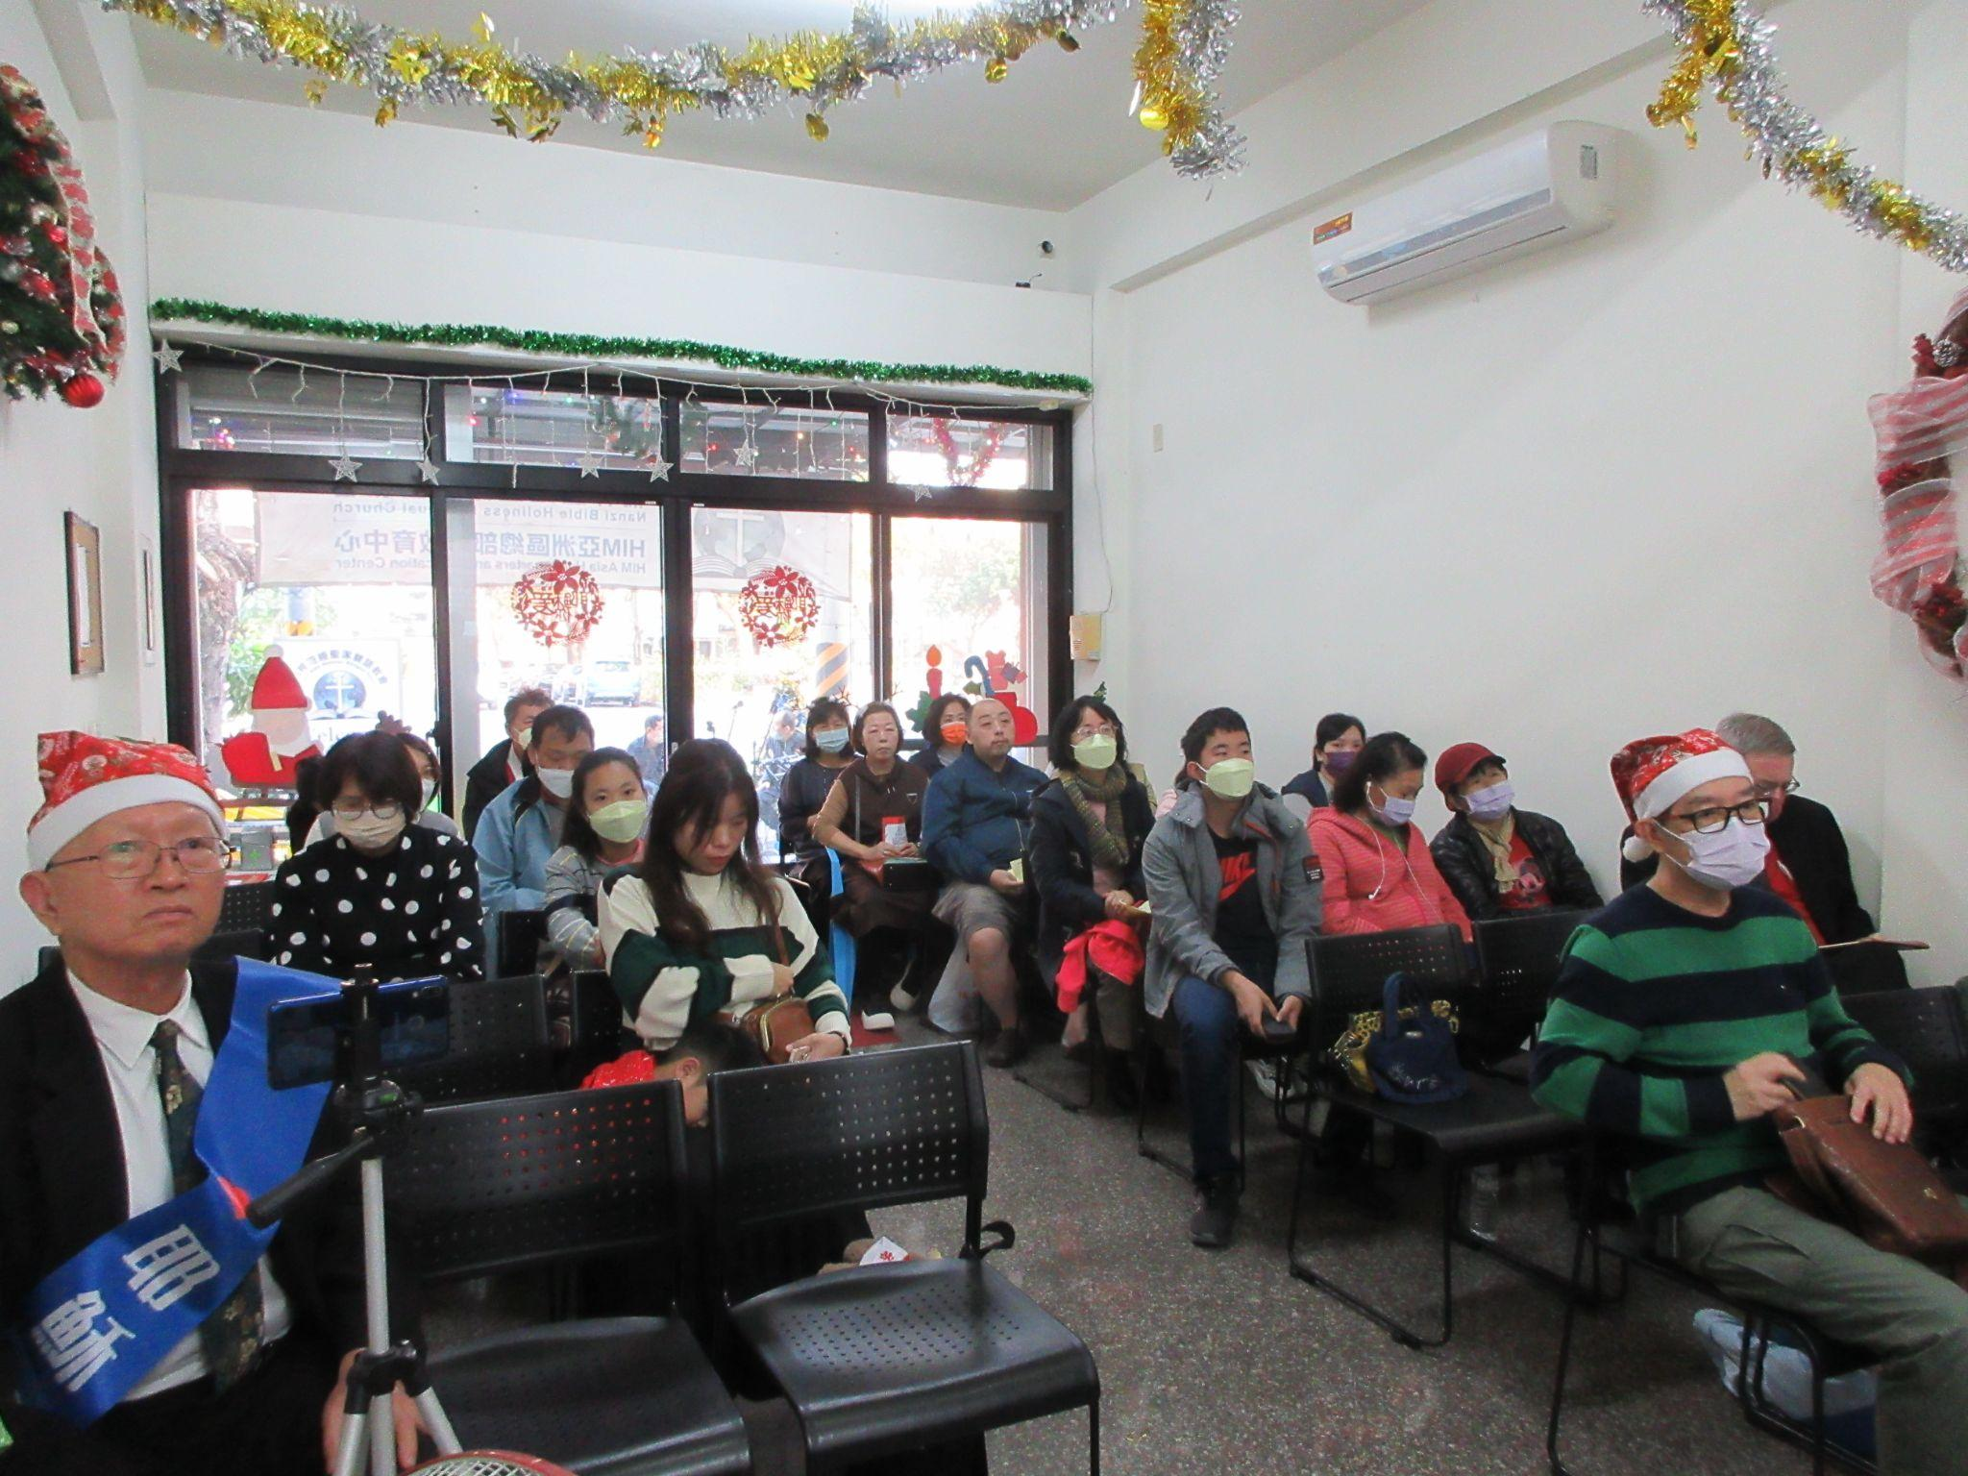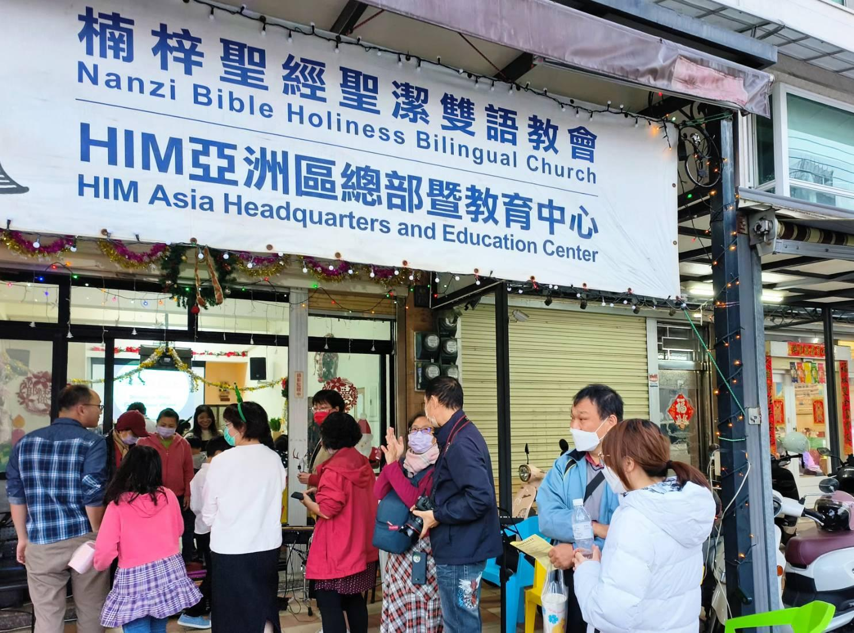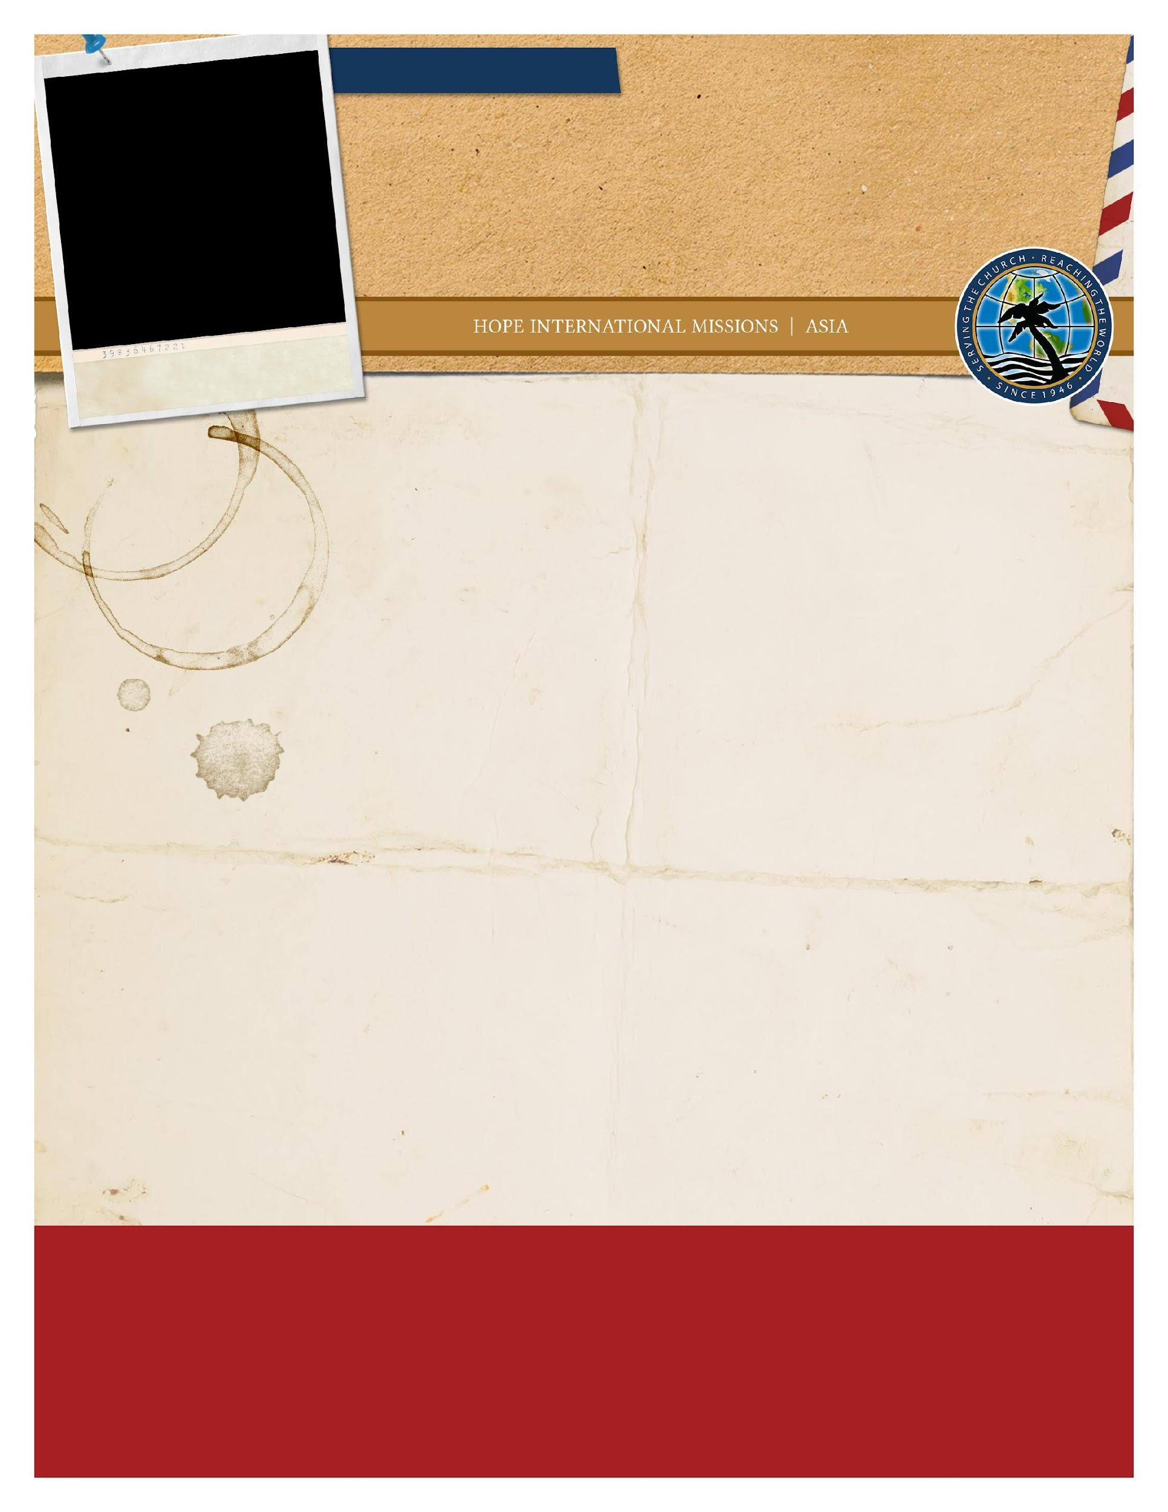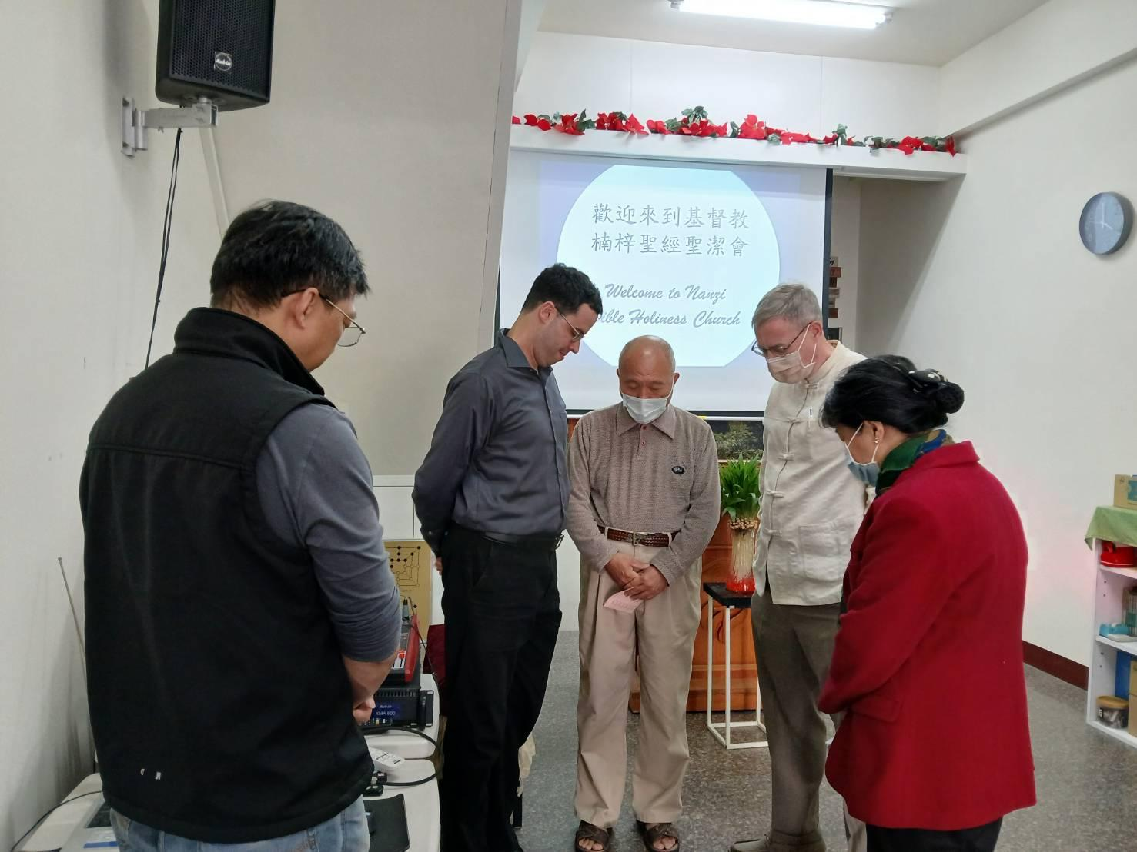

MARCH 2024

Inside Nanzi Church

Bible Study

Greetings to you and Happy New Year,

This Christmas has been most memorable. The church in Nanzi made a great effort to reach out during the Christmas season. In our Christmas Eve service we had eighty people in our small church.

This has been a time of celebrating the new year twice—the American and the Chinese New Years. It is hard to believe a year has passed since I have come here. Already this year much has happened. I was thrilled to have a visit from my parents. This was their first time to see me on the mission field. When you are familiar with another country, you tend to forget what is foreign to others. I had the privilege of showing them people and places which were only names and pictures before.

During February, Chinese New Year took place. This is the biggest holiday in many Asian countries. Most families take this time to visit each other, give gifts, clean house, and travel. I was spontaneously invited to one of these homes and met a new family. I also took some time to travel to Taipei and meet more people.

The church’s Bible study has grown significantly these past few weeks. Biblical translation and explanation have their challenges, but the effort is worth it. Throughout my time here, I have learned each person is distinct and precious in God’s eyes and learns about God from a different starting point. A Buddhist lady has come to our church for nearly six months now and has many questions. Another newcomer accepted Christ and is taking baptism classes to further understand who God is.

I thank you for your prayers and support this past year. I am grateful to be used of God here in whatever way He would choose for me. The gospel continues to move, but communication and ministry usually takes longer than we wish. Our Lord is patient with us all. He does not wish that any will perish but will turn to Him and repent (2 Peter 3:9).

May God bless you this day,

Nathanael Bundy

**Nathanael Bundy**

MISSIONARY TO TAIWAN

**WEB PAGE**

feaministries.org/missions/bundy

**EMAIL**

bundy@feaministries.org

**FACEBOOK**

www.facebook.com/nathanael.bundy

**SUPPORT ADDRESS**

Hope International Missions

PO Box 1065

Hobe Sound, FL 33475

Mark “Support for N. Bundy” in memo line.